**COMPUTER NETWORKS**

**LAB REPORT**

**ASSIGNMENT 6**

**DEBJIT DHAR**

**BCSE UG 3**

**ROLL:002210501106**

**GROUP: A3**

**SUBMISSION: 18/11/2024**

**Problem Statement: Creating Networks using Cisco Packet Tracer Software**

**PROBLEM 1:**

Connect two hosts back-to-back with a crossover cable. Assign IP addresses, and see whether they are able to ping each other.

**SOLUTION:**

Open Cisco Packet Tracer and from the lower right select pc and add two such into the workspace and connect via the dotted line (copper crossover connection) using FastEthernet0 of both. The PCs are named as PC0 and PC1 respectively.

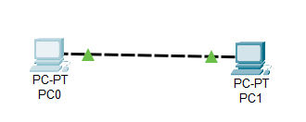

Next open PC0 and go to Desktop->IP Configuration. Set Ip address and subnet mask. Do the same for PC1.

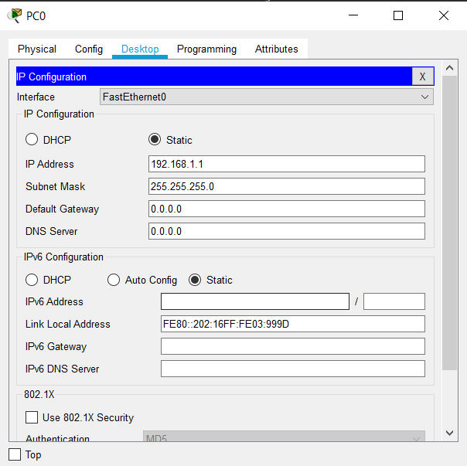 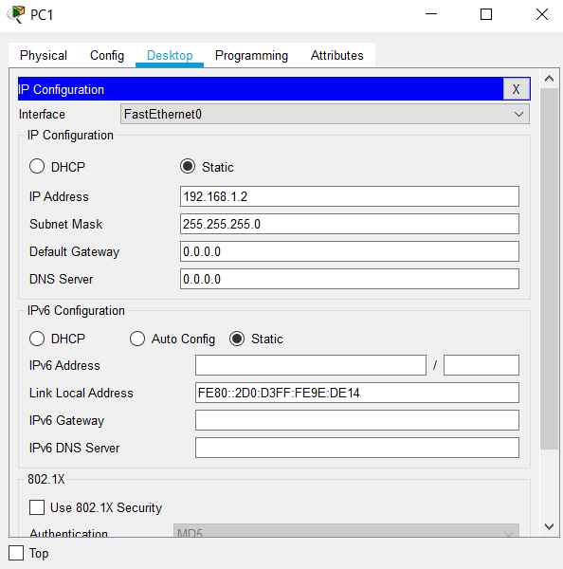

Then go to PC0->Desktop->Command Prompt and ping 192.168.1.2

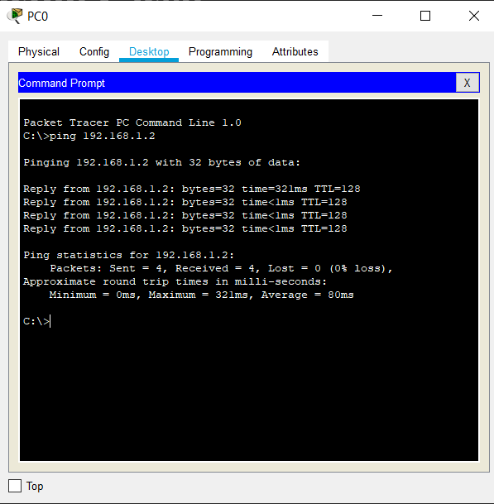

**PROBLEM 2:**

Create a LAN (named LAN-A) with 3 hosts using a hub. Ping each pair of nodes.

**SOLUTION:**

PC0->192.168.1.1/255.255.255.0,

PC1->192.168.1.2/255.255.255.0,

PC2->192.168.1.3/255.255.255.0

All PCs connected to hub by copper straight cable.

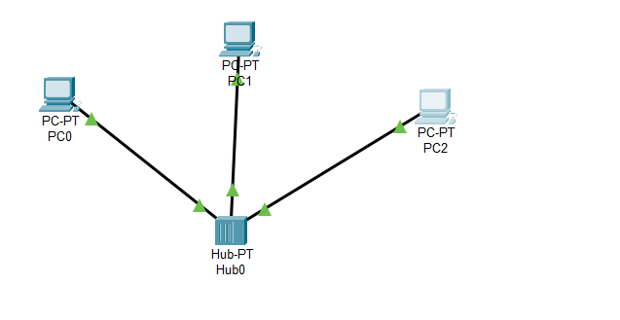

Pinging every other pc from every pc.

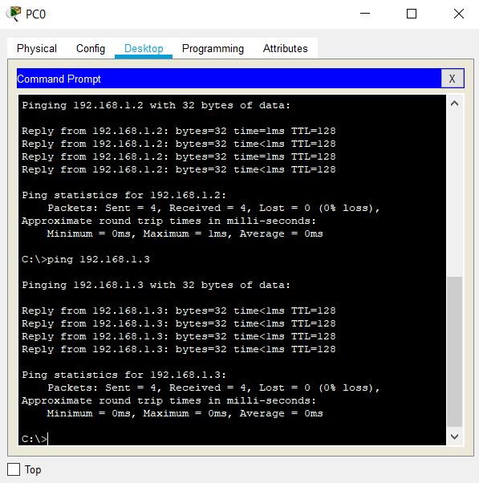 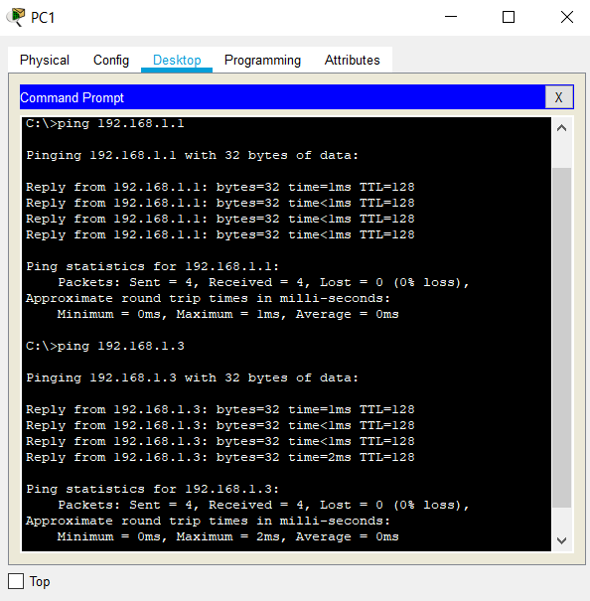 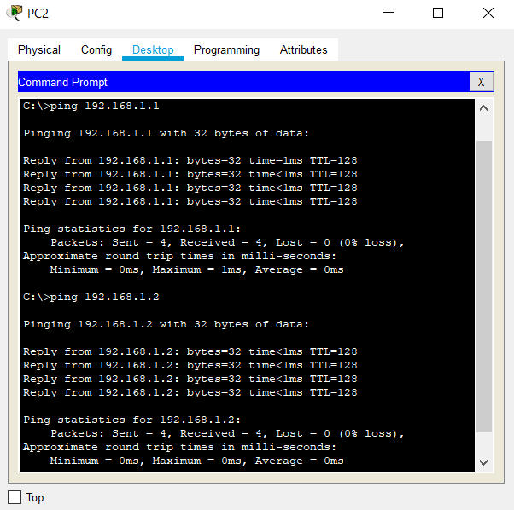

**PROBLEM 3:**

Create a LAN (named LAN-B) with 3 hosts using a switch. Record contents of the ARP Table of end hosts and the MAC Forwarding Table of the switch. Ping each pair of nodes. Now record the contents of the ARP Table of end hosts and the MAC Forwarding Table of the switch again.

**SOLUTION:**

PC 0->192.168.3.1/255.255.255.0

PC 1->192.168.3.2/255.255.255.0

PC 1->192.168.3.3/255.255.255.0

Use the 2960 switch and name it LAN B. Before pinging the arp tables of the hosts and the mac address table of the switch is empty. Now, ping each pair of hosts. The mac address table is observed in cli of switch and the arp tables through command prompts of respective hosts

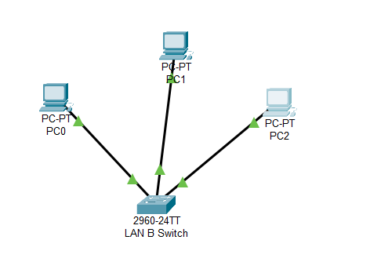

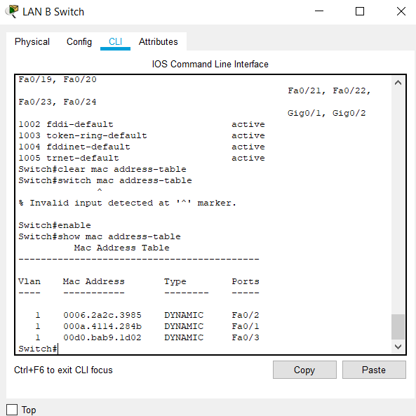

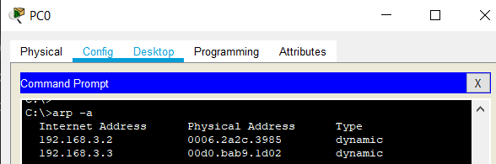 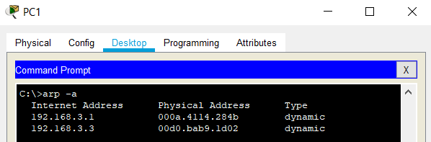 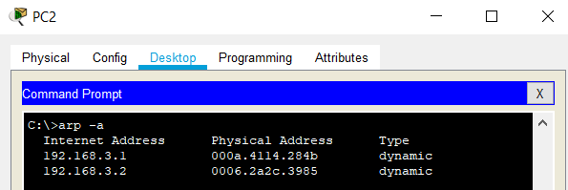

**PROBLEM 4:**

Connect LAN-A and LAN-B by connecting the hub and switch using a crossover cable. Ping between each pair of hosts of LAN-A and LAN-B. Now record the contents of the ARP Table of end hosts and the MAC Forwarding Table of the switch again.

**SOLUTION:**

LAN A contains the switch that is connected to Hub of LAN B via the copper crossover cable.

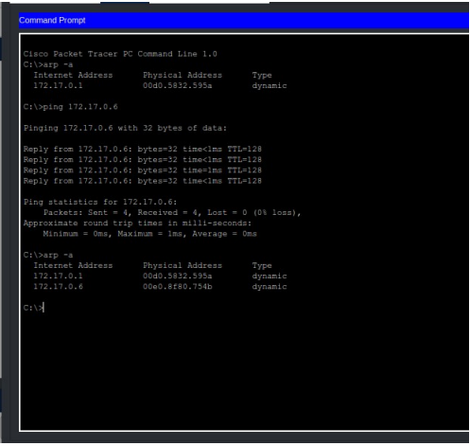

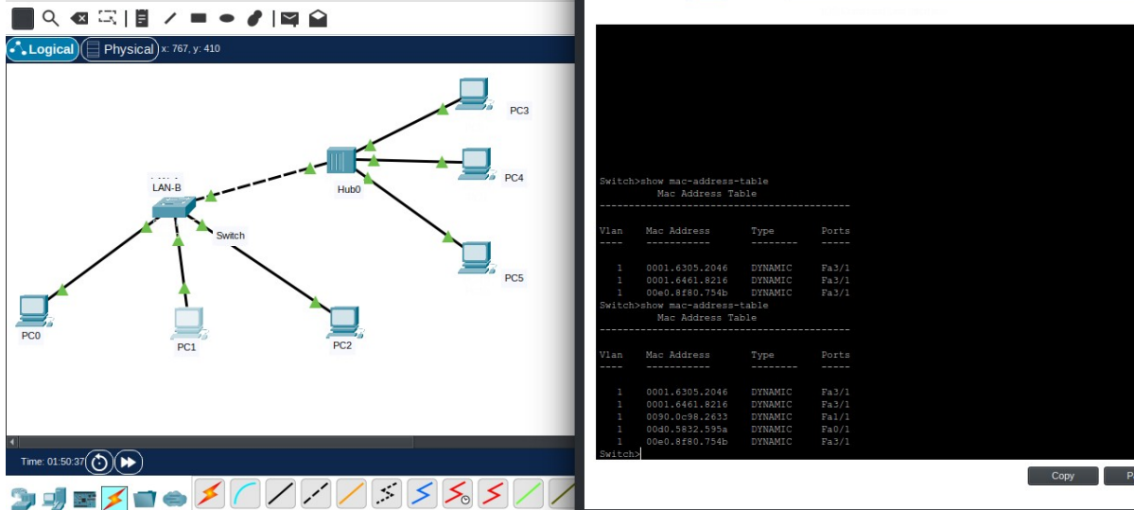

**PROBLEM 5:**

Create a LAN (named JU-Main) with three hosts connected via a layer-2 switch (Cisco 2950 switch PC-LAB1-Switch). Connect the switch to a router (Cisco 1818). Assign IP addresses to all the hosts and the router interface connected to this LAN from network 192.168.148.0/24. Configure the

default gateway of each host as the IP address of the interface of the router which is connected to the LAN.

Create another LAN (named JU-SL) with three hosts connected via a layer-2 switch (Cisco 2950 switch PC-LAB2-Switch). Connect this switch to another router (Cisco 1818). Assign IP addresses to all the hosts and the router interface connected to this LAN from network 192.168.149.0/24.

Configure the default gateway of each host as the IP address of the interface of the router which is connected to the LAN. Connect the two routers through appropriate WAN interfaces. Assign IP addresses to the WAN interfaces from network 192.168.150.0/24. Add static route in both of the routers to route packets between two LANs.

**SOLUTION:**

Steps- Firstly give ip addresses to all pcs. Then give ips to both ports of both routers and turn them on. Next configure the default gateway of each pc. Then configure the static routing and next hop of both routers.

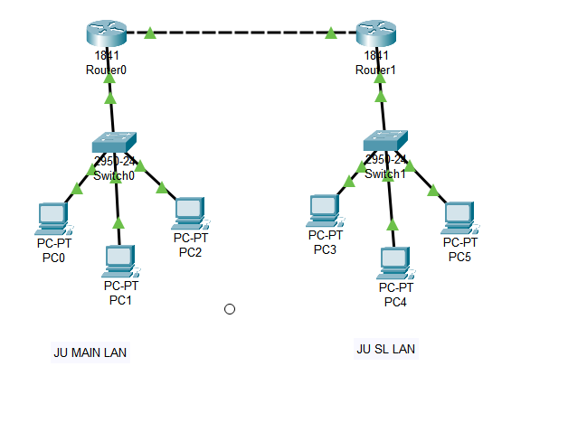

The LAN has been correctly configured as shown by these communications.





**PROBLEM 6:**

Add servers to the individual LANs (in problem 5) and configure them as a DHCP server. Configure the hosts in the individual LAN to obtain IP addresses and address of the default gateway via this DHCP server.

**SOLUTION:**

**PROBLEM 7:**

Create a LAN (CSE) with three hosts connected via a layer-2 switch (Cisco 2950 switch CSE-Switch). Also add a web server and a ftp server to this LAN. The hosts dynamically get their IP addresses from a local DHCP server. Servers are assigned fixed IP addresses. Configure the individual hosts to use the local DNS server for name resolution. Add a Domain Name Server (DNS) to this LAN. Create appropriate records in the DNS server for the individual servers in the LAN. The domain name of the LAN is cse.myuniv.edu. Configure the individual hosts to use the local DNS server for name resolution.

**SOLUTION:**